Talk Box (Speech Generating Device)

User Manual

Installation:

* Downloading jar File
* Running Jar file to customize buttons and voice inputs.
* Create very own customized talkbox application.

Here are the step for configurating the talkbox depending on user needs

1. Right after running the configuration, it asks for the required number of buttons:

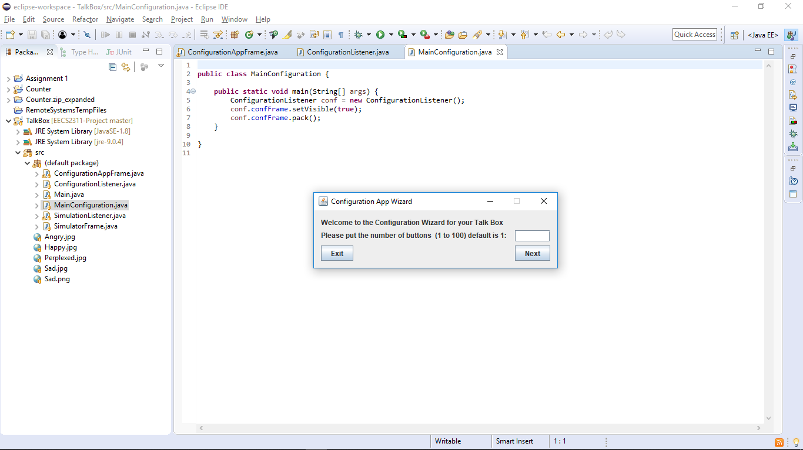

1. Creates the intended number of buttons and then prompts the user to upload the specified image and audio file. (unique to user needs)

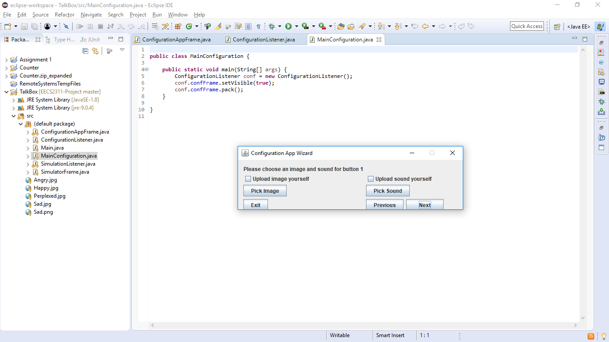

Major Use Cases:

In a more general sense, the main functionalities of the device are accepting audio files and text/images as input, and then outputting audio depending on the users needs.

Support the ability to function in school/workspace, support sociability. Used to voice certain emotions and states. Thus, enhancing communication when sensory, motor, and/or linguistic impairments are involved.

Limitations to the device include user input text to speech functionality, to help in outputting customized responses.